Git Repo: link
Screenshot:
1. The signed-in habit list
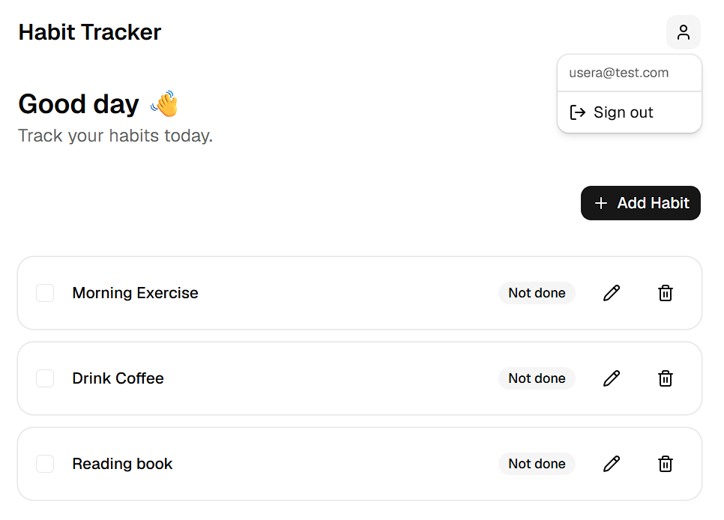
2. The second account’s empty list
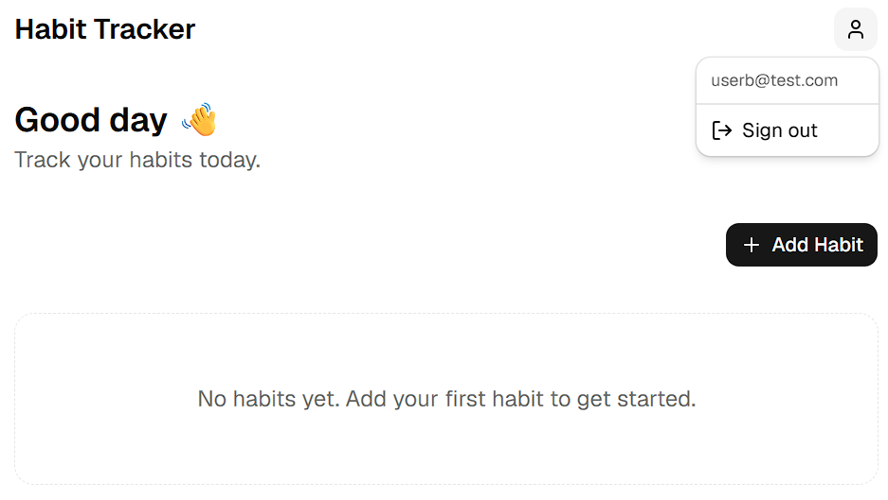
3. The SQL editor showing both policies
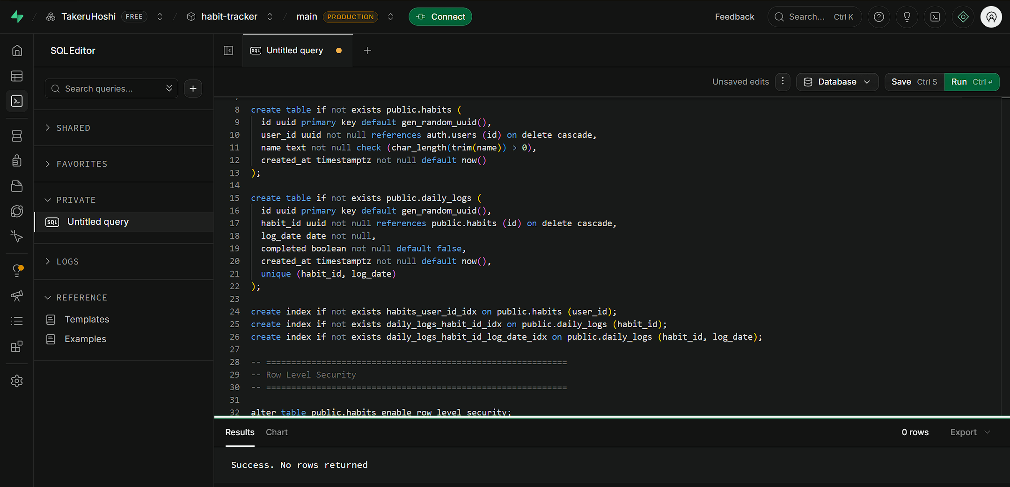
One sentence: what an attacker could do against your tables if RLS were disabled once the app is deployed.
With RLS disabled, anyone holding the public anon key (visible in any deployed frontend's JS bundle) could directly call the Supabase REST API to read, modify, or delete every user's habits and daily logs - no login required, since the anon key alone authenticates the request and there'd be no auth.uid() = user_id check left to stop it.

